EXPT 1 :Simulation-Based Electromagnetic Analysis of TEM, TE and TM Propagation Modes in Microwave Transmission Structures
AIM: To simulate and analyze a 50 Ω microwave transmission line and two-port network using MATLAB by determining the S-parameters (S11, S12, S21, S22), return loss, insertion loss, transmission efficiency, and optimum operating frequency over the frequency range of 8–12 GHz
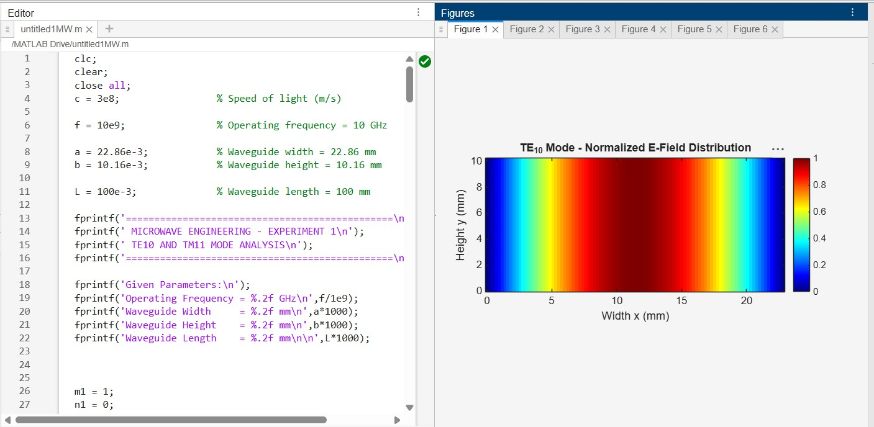

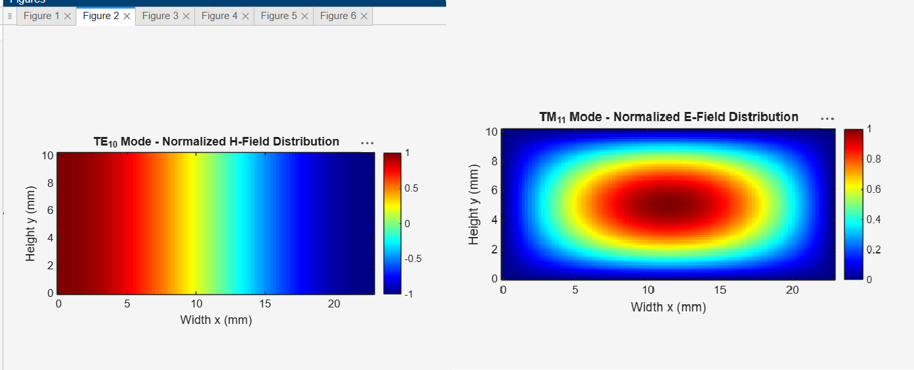

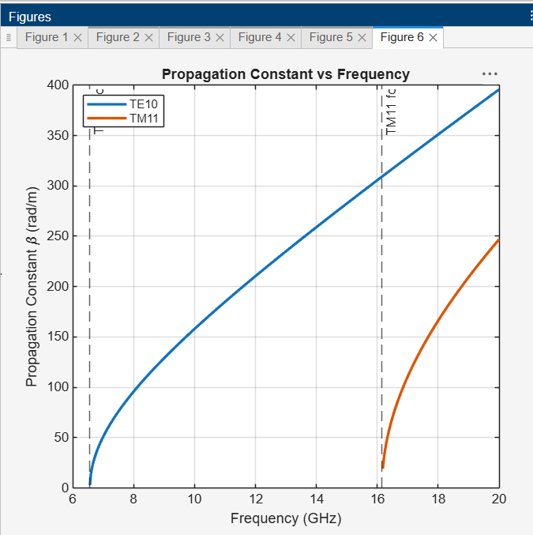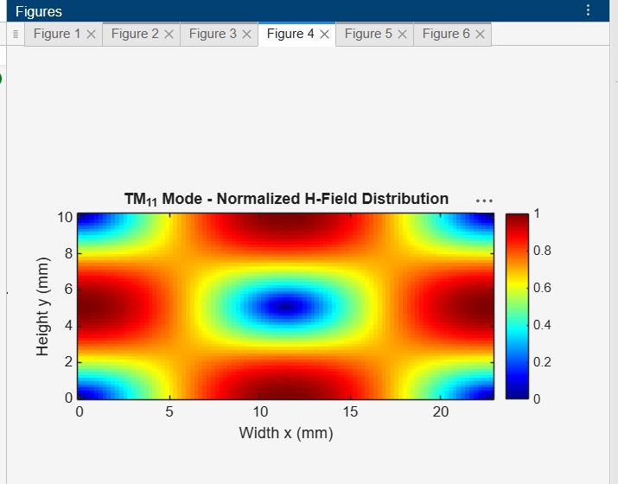

RESULT
The microwave transmission line and two-port network were numerically simulated using MATLAB. The S-parameters were analyzed, and the return loss, insertion loss, and
transmission efficiency were calculated. The optimum operating frequency was identified based on minimum input reflection and maximum forward transmission.

